Cleaning data by removing NaN in date field and replacing it with the correct data

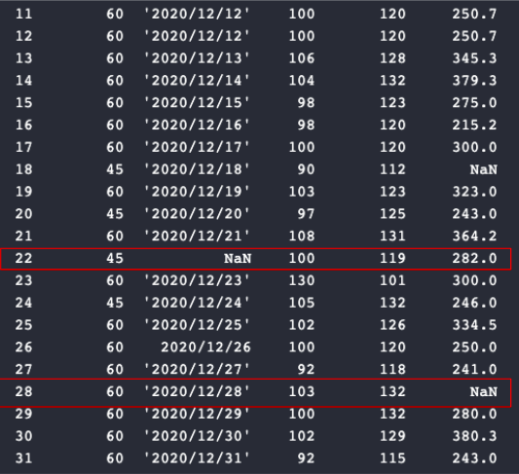

In order to get the results below, I used this code as my solution:

I first imported pandas as pd, and then defined the data set as a data frame by passing the name of the csv file into the .read_csv function. To solve the problem of having NaN values in the dataset, I then used the .fillna function for both the date and the calories, which are NaNs. I finally converted the dataframe as a string and printed it as a result.

